Linux session-2

mkdir – making directory

touch filename – create a file

cat filename – to view the file

cat filename .txt - to view the text in the file

d rwx – directory

-rwx – file

Chmod – change modification (changing the permissions for owner, groups, other)

R – Read 4

W - write 2

X – execute 1

Chown root:root filename (root-> username)

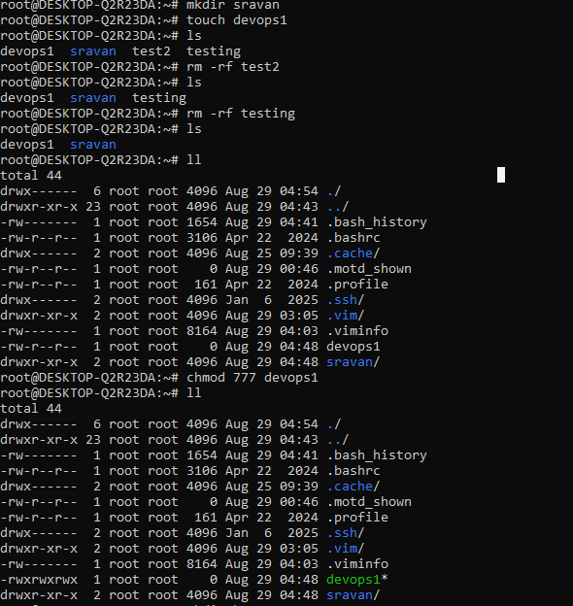

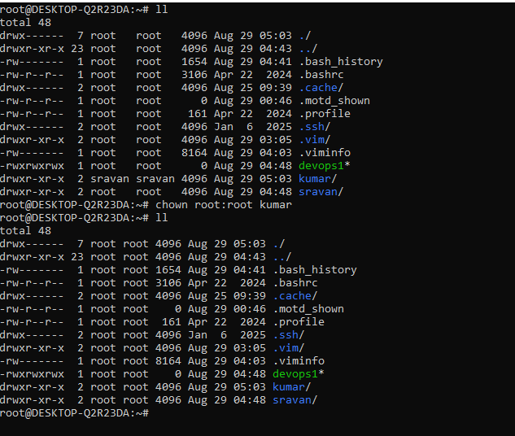

cat /etc/passwd - To check the list of users

useradd filename - To create user

passwd username - To create the password

su username - to switch user

find / -name filename - to check all the files

find –name filename - to check only one file

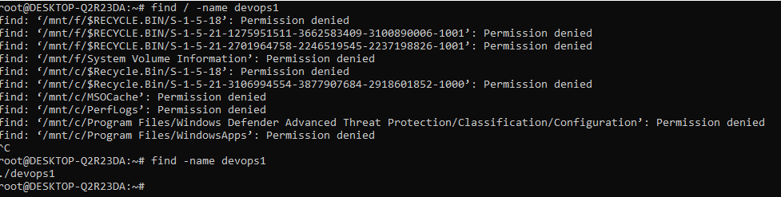

I/O redirections

echo “hello world”

echo “hello world” > test1 single redirection can override existing file or rename  
  
echo “devops” >> test1 double redirection It combines the files

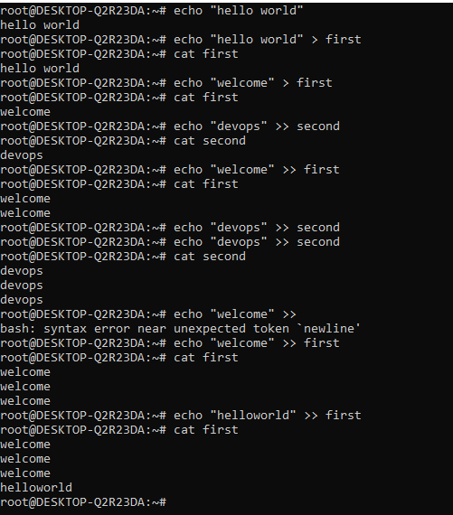

head -3 filename - show first 3 lines

tail -2 filname - show last 2 lines

tail -f filename - continosully moniter the file

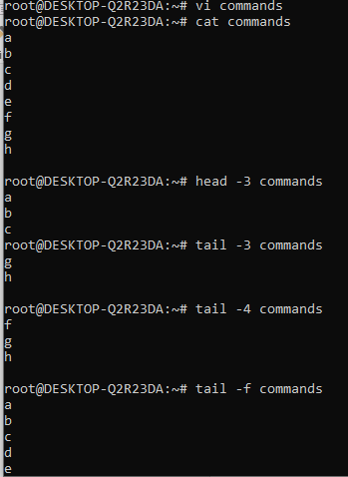

find / -name \*.text - to find files with .txt extension ( \* represents all )

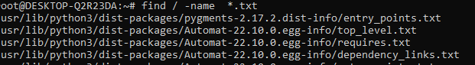

find / -name filename -mtime +30 - shows a file olderthan 30 days

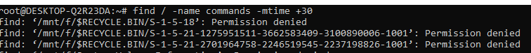

grep key filename - to find particular keyword

grep -I key filename - finding a keyword either capital or small word

